STANDARD OPERATING PROCEDURE
Market Research
How to carry out complete market research (including competitor analysis) for a brand.
SOP-01 • Version 1.1 • Stage 1 of 7 in the cycle
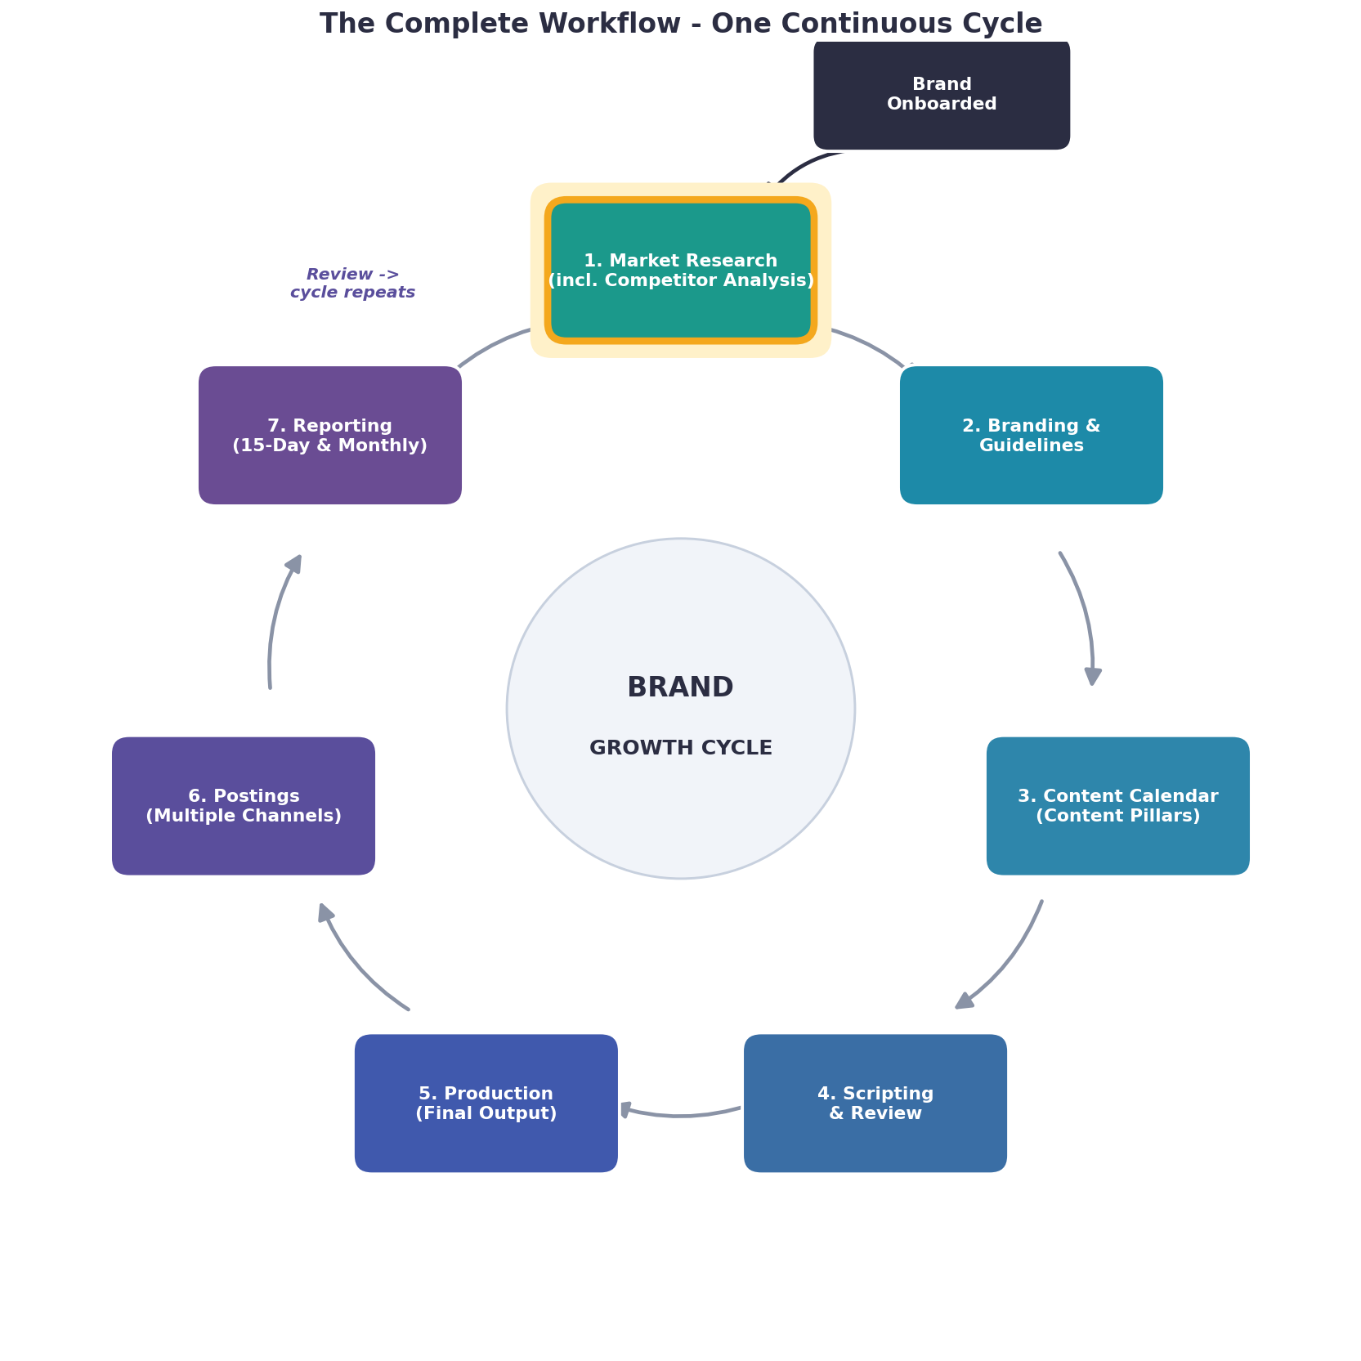
The full workflow cycle. This SOP covers the highlighted stage: Market Research.
SOP ID | SOP-01 (Version 1.1)
Starts when | A brand is onboarded, OR a reporting cycle finishes and research needs refreshing.
Primary owner | Team Lead (with Social Media Manager & Graphic Designer)
Typical turnaround | 3 to 5 working days (new brand); 2 to 3 days (refresh).
Output goes to | Branding & Guidelines (SOP-02) and Content Calendar (SOP-03).

Purpose & scope
This SOP explains how to research a brand, its audience, its market, and its competitors, and turn the findings into one clear market research document. It is followed every time a new brand joins and every time the cycle repeats after reporting.
Roles & responsibilities
Note: Your team has four roles: Team Lead, Social Media Manager, Graphic Designer, and the Content Team (production). Where a stage is shared, adjust the exact split to match how you work.

Role | Responsibility in this stage
Team Lead | Owns the stage, confirms the brand's goals, reviews the research, gives final approval, and handles client communication.
Social Media Manager | Carries out the research and competitor analysis and writes the document.
Graphic Designer | Studies competitors' visual style and content formats and notes design opportunities.

What you need before you start (inputs)
- Signed onboarding form and the client's basic details.
- Brand website and existing social media profiles.
- Any brand material the client shares.
- For a repeat cycle: the latest performance reports from the Reporting stage.
Procedure (step by step)
1. Team Lead collects the onboarding information and shares it with the Social Media Manager.
2. Social Media Manager studies the brand: products, services, history, and current situation.
3. Team Lead confirms the brand's goals and objectives.
4. Social Media Manager researches the target audience and builds 2 to 3 audience personas.
5. Social Media Manager studies the market: its size, growth, trends, opportunities, and challenges.
6. Together the team identifies the 3 to 5 main competitors.
7. Social Media Manager records each competitor's offer, positioning, strengths, weaknesses, content types, posting frequency, and engagement; Graphic Designer notes their visual style and content formats.
8. Social Media Manager does a SWOT analysis of the brand.
9. Team Lead and Social Media Manager define the brand's positioning and Unique Selling Point (USP).
10. The team identifies the best platforms and current content opportunities (topics, formats, hashtags, seasonal events).
11. Social Media Manager compiles everything into the market research document using the standard template.
12. Team Lead reviews the document and adds strategic direction.
13. Team Lead approves and shares it internally and, if needed, with the client.
Quality checkpoints
- Every section of the template is filled in.
- At least 3 competitors have been analysed.
- Personas are based on real signals, not guesses.
- The findings clearly lead to the recommendations.
Output & hand-off
Output: One complete market research document (including competitor analysis). It is handed to the Branding & Guidelines stage and used to build the Content Calendar.
Do's and don'ts
Do:
- Base every recommendation on evidence.
- Keep competitor data current.
- Save the document in the shared brand folder.
Don't:
- Do not copy a competitor's strategy - look for gaps instead.
- Do not skip the audience personas.
- Do not start branding before this is approved.

